**TASK.SH**

Step1: Create the instance after connecting the server

* Sudo su –
* Apt update -y

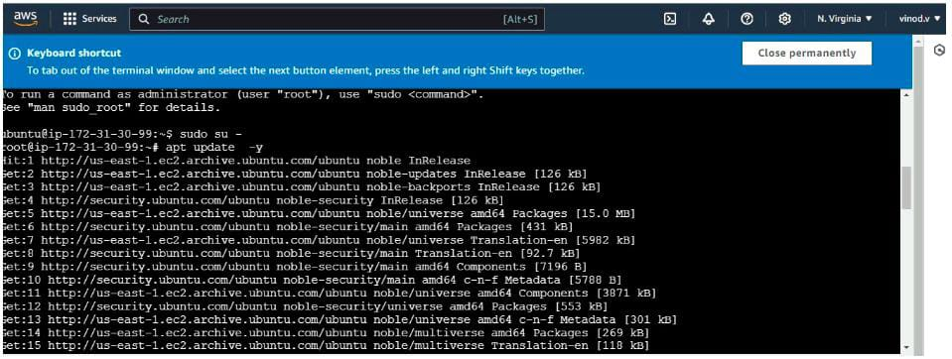

Step2: Aws configure

* Aws configure
* Snap install aws-cli –classic

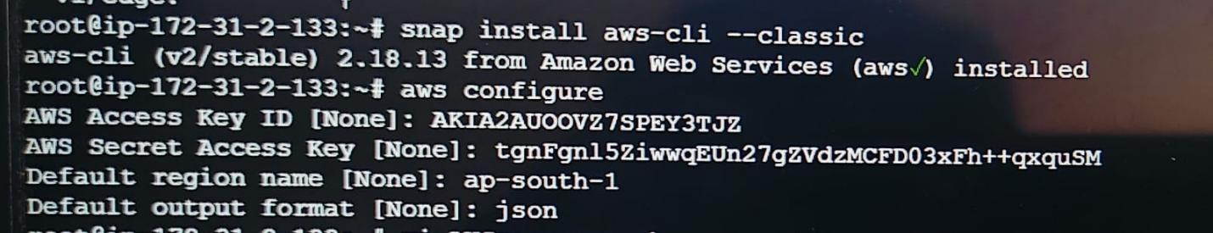

**GIVEN:**

* Acess key : AKIA2A2AUOOVZ7SPEY3TJZ(From iam user)
* Secret key: tgnfgn15ziwwqeun27gzvdzmcfd03xfh++qxqusm
* Region : ap-south-1
* Foramt : json

Step3: Open file by giving command: vi AWSresource.sh

Step4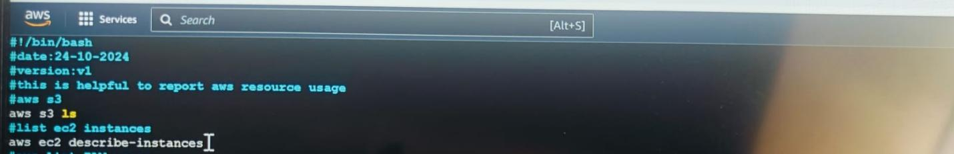: Write the script inside the file and save the file like given bellow file

Step5: use commands

* chmod 700 Awsresource.sh
* ./AWSresource.sh

Then the file open likes below

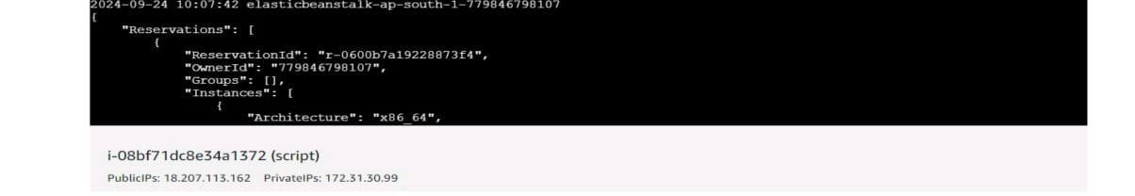

Step6: IAM list users

* Vi AWsresource.sh( add the script) given bellow
* Add: #aws list IAM users

aws iam list-users

* Save it by wq!

Step7: output

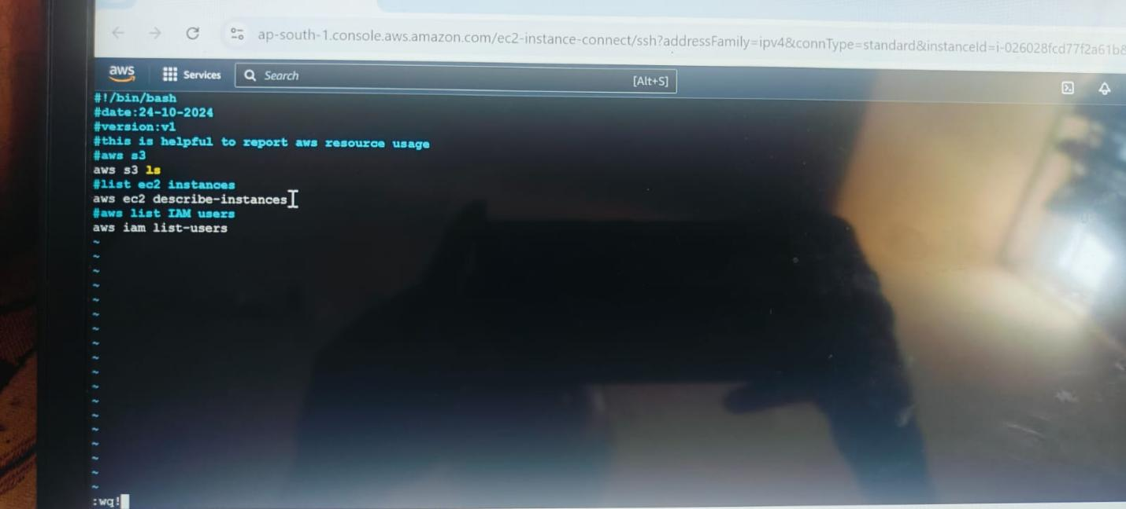

Out put was like this

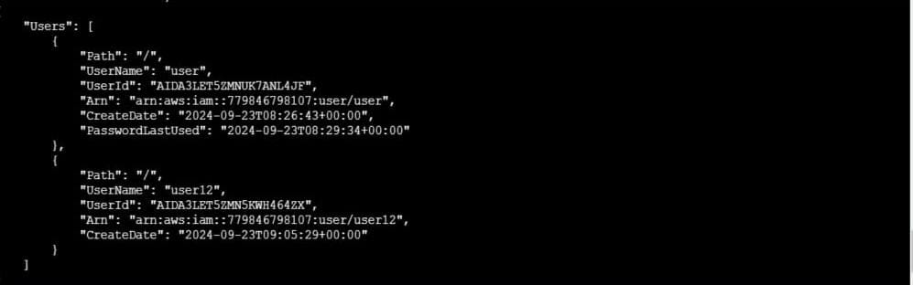

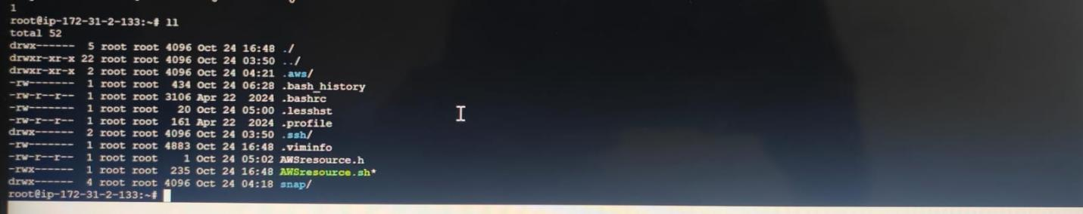

Step8: De buging mode run inside the script

* Vi AWSresource.sh(add the bellow script) 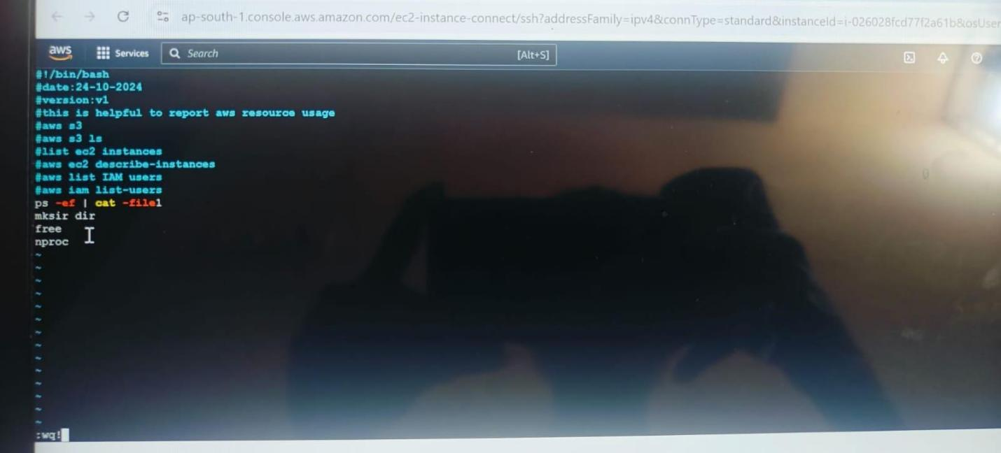
* Output was like this

